Application Number | 07/2019/12053/FUL
Address | 25 Chapel Brow, Leyland
Applicant | Mr A Hafiz

Agent Roger Treacher
Hughes Treacher
Farrers Farm
Grange Lane
Hutton

Development | Retrospective change of Use from office (A2) to Place of Worship (D1) including part two storey/part single storey rear extension and associated internal alterations
Officer Recommendation | Approval with Conditions

Date application valid | 13.12.2019
Target Determination Date | 07.02.2020
Extension of Time | 06.03.2020

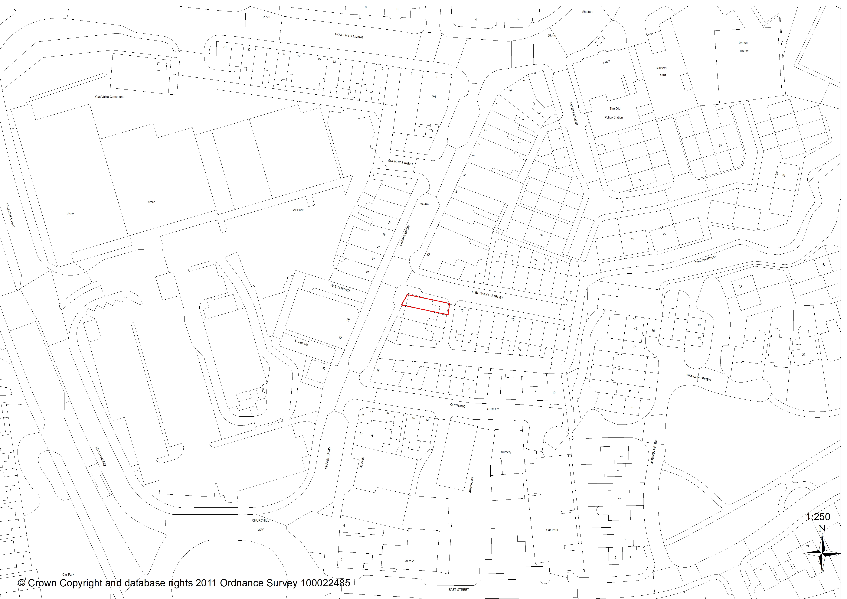

- Introduction

This application was deferred by Committee in February 2020 to allow further dialogue with regards to reducing the proposed extension

- Report Summary

  - The applicant seeks permission for retrospective change of use of 25 Chapel Lane, Leyland from an office (use class A2) to a Place of Worship (class D1), with proposed part two storey/part single storey rear extension and associated internal alterations.

  - No: 25 is a typical, end of terrace property at the junction of Chapel Brow and Fleetwood Street. A small yard and alleyway are present at the rear. Premises in mixed commercial/residential use lie to north and south, and face across Chapel Brow. Properties to the rear are residential in nature. The site and immediate surroundings sit within the secondary retail area of Leyland Town Centre as designated by Local Plan Policy E3.

  - The property which is currently laid out as a two bedroomed terrace dwelling but used as a place of worship, would be altered to provide more functional meeting, hallway and toilet/shower rooms at ground floor, and an open plan meeting room at first floor. Amenity space is limited to a small yard at the front. An internal waste store to the rear would be provided. Use of the building itself is detailed in full at Para 5.2 (below).

  - Background Information: It is not unlawful to undertake development without planning permission unless the development has been previously refused or conflicts with an enforcement notice issued by the Council. The site has operated as a place of worship without permission for a little over 9 years, and the applicant wishes to regularise the situation.

  - Section 171B of the Town & Country Planning Act however states that development becomes immune from enforcement action if no action is taken within 10 years of any breach of planning control. This includes changes of use where the new use has been in place continuously for 10 years or more. Sections 191-193 of the same Act allow for applicants to certify the lawfulness of a use where the applicant can evidence this ten-year use, after which the new use becomes the lawful one. Notwithstanding the proposed extension and regardless of this decision, it should be noted that the Islamic Centre has been used as such for a little over 9 years and may be the subject of such a lawfulness application in less than 12 months’ time.

  - In response to two separate rounds of publicity 5 letters of representation have been received; all refer to the initial, larger extension not the later reduced scheme. These are detailed at Para 7.2. Comments raised by statutory consultees have been dealt with either by amendments to the scheme or by condition

  - Having regard to the extended use of the building without obvious issue, in policy and spatial separation terms the proposed change of use and extension of 25 Chapel Brow are considered compliant. It is therefore recommended that the application should be approved subject to the imposition of conditions

- Application Site and Surrounding Area

  - No: 25 is a typical end of terrace property facing Chapel Brow, and whose side elevation faces Fleetwood Street. A small yard and alleyway are present at the rear. Premises in mixed commercial/residential use lie to north and south, and face across Chapel Brow. Properties to the rear are residential in nature. The site and immediate surroundings lie within the secondary retail area of Leyland Town Centre as designated by Local Plan Policy E3.

- Site Context / Planning History

- 07/1987/0378 – Change of use of offices. Approved July 1987
- 07/2010/0557/FUL - Change of use from offices to shop with flat at first floor. Single storey extension and external staircase to rear. Approved October 2010 but does not appear to have been implemented.

- Proposal

  - The application originally proposed change of use of the property to a place of worship (use class D1) and two storey extension to the rear. At the request of Planning Committee, the proposal has since been changed to a part two storey/part single storey extension. Change of use and internal alterations have not however changed. The property which is currently laid out as a two bedroomed terrace dwelling but has been used for the proposed purpose for around nine years would be altered to provide useable meeting, hallway and toilet/shower rooms at ground floor, and an open plan meeting room at first floor.

  - Change of Use - The applicants statement says that winter prayers occur 5 or 6 times a day for 30 minutes between 6.45am and 8.30pm. The most popular prayer time is 1.45pm which from Saturday to Thursday is attended by between 10 and 15 people. This increases on Friday to around 40 people. In summer attendance is less frequent. A check of the centres website also notes that attendees are actively encouraged to avoid congregation or excessive noise at the premises, to park away from adjacent residential streets and use public car parks on East Street, the Railway Station and Churchill Way. Private off-road parking is not available, but this is no different to all commercial and residential premises in the area. There are no recorded Planning Enforcement or Environmental Health complaints directly related to use of the property as a place of worship.

  - The Councils Council Tax system notes that exemption from payment since September 2010 has been agreed, and anecdotal evidence confirms that the use has been in place for some time.

  - Extension - The proposed extension has been reduced from 6m to 5.8m deep at ground floor, and 3m deep at first. It would be 4.6m wide and would have a flat roof at ground floor measuring 2.5m high. The two-storey roof would be mono-pitched into the existing roof plane at 4.6m – 5m high (reduced by 300mm) but would sit behind the existing two storey outrigger. Amenity space would be limited to a small yard at the front. Waste storage would be kept in an internal store accessed via new door from Fleetwood Street. Stores of this type are not unusual for commercial premises, but as a precaution a condition to prevent storage on the highway or in the front garden (other than on the day of collection) is felt necessary.

- Summary of Supporting Documents

  - The application is accompanied by the following:
- Design & Access statement (Nov 2019: Hughes Treacher)
- Existing floor plans, elevations & sections (1904/02A: Hughes Treacher)
- Proposed elevations/sections (1904/04 E: Hughes Treacher)
- Proposed floor plans (1904/03/E: Hughes Treacher)

- Representations

  - Summary of Publicity

    - A site notice has been posted, and 58 neighbouring properties consulted on three occasions. The Ward Councillor who called this application into Committee was also notified

  - Letters of Objection or Support

    - Five letters of representation have been received; two of whom do not object to the buildings use as a place of worship but whose comments are included in the summary of objections below:

Highways
- Existing parking and delivery problems on Fleetwood Street / Chapel Brow to adjacent business with ‘Friday appearing to be the worst day’. Respondent highlights Friday as being the highest attendance to the proposal site; formal change of use would exacerbate the situation
- Respondent asks for reassurance that attendees would not use Fleetwood Street to park, and that this would be enforced
- Traffic impact during construction

Other
- Disruption during construction – request for assurance from applicant that this will be correctly managed, and traffic will not use Fleetwood Street.
- Concern that the extension will cover existing drains
- Window proposed to the rear would face a public footpath on Fleetwood Street, and would result in lost privacy to users of the toilet/washing area. Suggestion that the window is relocated to the back alley – the proposed window now faces the back alley and would be obscurely glazed in line with Building Regulations.
- Lack of waste storage area – the proposal has since been amended to allow for an internal waste store.
- The original description did not refer to a retrospective proposal. This was noted by Officers prior to receipt of representation and relevant paperwork/consultation updated.

Officer Comment in Response: Parking availability on Fleetwood Street and Chapel Brow are limited, but there is no evidence to prove one way or the other that problems in this mixed-use area lie solely with the place of worship, which has been in use for many years. Public parking is available on Churchill Way, in Leyland Town Centre and at the Railway Station, and as mentioned at Para 5.2 the applicant actively promotes use of these areas for its patrons. Parking during construction would be dealt with as part of the Construction Management Plan secured by condition.

Any vehicle may park on any public highway without restriction, and unless Fleetwood Street is restricted in some way by the Highways Authority (e.g. residents parking only) this must be given due weight. Para 109 of the NPPF also states that ‘Development should only be prevented or refused on highways grounds if there would be an unacceptable impact on highway safety, or the residual cumulative impacts on the road network would be severe’. The Highways Authority however has not objected.

    - One resident wishes to note that the centre has operated as a Mosque/Islamic Centre for many years, that he has no objection to its use, and his relationship with the applicant has been cordial throughout. The centre however attracts people from a wider area and if its popularity wanes ‘would have been expanded to no purpose’. He also wishes to object to the proposed extension which would impact upon his quality of life and current view and sense of openness. There is no right to a view in planning law, but the proposal was originally, and has since its reduction been assessed against the separation standards adopted by the Council to ensure that any loss of amenity is in relative terms acceptable. Respondent also suggests an alternative, reduced scheme but it is the remit of the planning system only to assess proposals put before it.

    - The following comments have also been made which are not material planning considerations, and as such have not been taken into account:

- The property has been in use as a place of worship for many years but as planning permission is not in place, they have not paid Business Rates at the relevant level
- Concerns re: fire escape – this would be covered by separate Building Regulations

- Summary of Responses

  - Lancashire County Council Highways has assessed the information provided by the applicant and after undertaking a site visit had the following comments. These do not change with the reduced extension:

‘The proposed extension will remove all outside storage space and the applicant should be aware that no bins are to be stored on the adopted footways; this includes the adopted alleyway behind the property’ – a condition to this effect is included

‘The site does not provide any off-highway parking however it is located within Leyland district centre in a highly sustainable location with good access to public transport and car parks. I have checked Lancashire County Council's five-year data base for injury related vehicular accidents. The database indicates that there have been no reported incidents within the vicinity of the site. LCC Highways is of the opinion that proposals would not have a severe impact on highway safety or capacity within the immediate vicinity of the site. Therefore, LCC Highways has no objections to the application’.

  - Lancashire Constabulary have not responded but this is not unusual as comments are only offered where advice specifically relating to crime is required.

  - Environmental Health recommend that conditions are imposed with regards to hours of construction. They also request that prior to installation of any external speakers in the future, details are submitted for agreement by the Local Planning Authority. The applicant has not indicated that these would be installed, but as they are often found on places of worship and some do not require planning permission a precautionary pre-installation condition is recommended.

- Material Considerations

  - Site Allocation Policy

    - The site is designated as Secondary Retail Frontage by Local Plan Policy E3 (Leyland Town Centre). This policy seeks to protect and enhance the viability and vitality of the areas shopping offer; requiring that a minimum of 60% of the units are of A1 use. The policy also encourages A3 (café/restaurant) and A4 (drinking establishment) uses, and permits other uses subject to appropriate assessment

    - Policy E3 in addition states that ‘redevelopment of existing sites, extension and/or change of use of existing buildings in the Town Centre will either be expected to use existing car parking facilities within the town centre (if in close proximity) or provide the appropriate level of car parking based on their location and type of development’.

    - The property - prior to its current use - was a residential property (C3 class), and as such there is no loss of ‘A’ use to the area. The latest assessment however shows that Leyland Town Centre already maintains 64% of ‘A’ class uses (including a small number of vacant premises with ‘A’ use potential) and as such any change would be compliant with Policy E3.

  - Additional Policy Background

Additional policy of marked relevance to this proposal is as follows:

    - National Planning Policy Framework (2018)

9.2.1.1. Chapter 2 (Achieving Sustainable Development) includes a presumption towards sustainable development across a number of different objectives; one of which is a social role which includes ‘fostering well designed and safe environments … that reflect current and future needs and support communities’ health, social and cultural well-being’

9.2.1.2. Chapter 6 (Building a Strong Competitive Economy) at Para 83(d) states that planning policies and decisions should enable amongst other things ‘the retention and development of accessible local services and community facilities, such as … meeting places … cultural buildings … and places of worship’.

9.2.1.3. Chapter 8 (Promoting Healthy Safe Communities) – Para 92 aims to provide the social, recreational and cultural facilities and services the community needs. Planning should plan positively for the provision and use of shared spaces, community facilities (such as local shops, meeting places, sports venues, open space, cultural buildings, public houses and places of worship) and other local services to enhance the sustainability of communities and residential environments;

9.2.1.4. Para 95 of the same chapter promotes public safety by anticipating and addressing possible malicious threats, especially in locations where large numbers of people are expected to congregate including places of worship

9.2.1.5. Chapter 9 (Promoting Sustainable Transport) at Para 109 states that ‘Development should only be prevented or refused on highways grounds if there would be an unacceptable impact on highway safety, or the residual cumulative impacts on the road network would be severe’.

9.2.1.6 Chapter 12 (Achieving Well Designed Places) – the creation of high-quality buildings is fundamental to what the planning and development process should achieve; good design being a key aspect of sustainable development.

    - Central Lancashire Core Strategy

      - Policy MP: states that the Council will take a proactive approach which reflects the NPPF’s presumption in favour of sustainable development, and that applications which accord with the policies of the Local Plan will be approved without delay unless material considerations indicate otherwise.

      - Policy 25 (Community Facilities) Ensures that local communities have sufficient community facilities provision working with public, private and voluntary sector providers to meet demonstrable need and encouraging and coordinating new provision at locations that are accessible by all modes of transport. Community facilities – including places of worship - facilities act as the focus of community activity and contribute towards community cohesion. Community facilities are provided by a wide variety of agencies, including … churches and other religious organisations, and the voluntary and business sectors

      - Policy 17 (Design of New Buildings) requires new development to take account of the character and appearance of the local area.

    - South Ribble Local Plan

      - Policy F1 (Parking Standards) requires all development proposals to provide car parking and servicing space in accordance with parking standards adopted by the Council.

      - Policy G17 (Design) of the same document attaches great importance to the design of the built environment, requiring proposals to take account of the character, appearance and amenity of the local area, and to highways and pedestrian safety.

9.2.3.2. Policy H1 (Protection of Health, Education and Other Community Services and Facilities) - The Council wishes to protect, enhance and accommodate new community facilities where appropriate.

  - Other Material Considerations

    - Character and Appearance, and Relationship with Neighbouring Properties

      - The proposal takes two parts. Firstly, the applicant wishes to regularise a situation which has occurred for approximately 9 years. The building has been in informal use as a place of worship for many years and planning permission for that change is requested. There is no recorded history to the Council of problems resulting from the buildings use.

      - Secondly, the buildings internal layout has been less than satisfactory for this purpose and as such internal reconfiguration and an extension to the rear is proposed. The part two storey/part single storey extension sits wholly within its own curtilage and allows for waste storage within the site. Amenity space is limited but this is not unusual in this traditional terraced locale. Similarly, rear single and two storey extensions are to be found on a number of similar properties in the area.

      - The South Ribble Residential Extensions SPD which is used as a guide for other developments requires a minimum of 21m between directly facing habitable room windows and 13m from a facing habitable room window and any blank wall or gable. Proposed first floor windows would face the blank side elevation of no: 16 Fleetwood Street at 3m distance. The proposed side elevation (doors at ground floor only) would face the side of 23 Chapel Brow (Indigo bar non-habitable rooms) at 10m separation. No 27 is attached in the south and beyond is no: 29 Chapel Brow. The proposed side elevation would be around 7m from this properties kitchen window which faces towards the extension but is screened by no: 27’s outrigger and walls to all properties. The only ground floor window would be obscurely glazed, and the only other property within the vicinity is no: 1 Fleetwood Street which indirectly faces the reduced extension at 16m. Spatial separation in this case is considered acceptable.

      - In design and usage terms, the proposal is likely to be similar in its impact upon neighbouring properties and is considered policy compliant.

    - Highways

      - Objection has been made with regards to the impact that the proposal would have in terms of parking on adjacent streets. It must be borne in mind however that little will change as usage is expected to be the same. The extension would be used by existing worshipers with internal re-arrangement only to make a more workable space. LCC as the Highways Authority have assessed the situation and have no objection

    - Community Infrastructure Levy

      - D1 (non-residential institutions) uses are classed by the CIL charging structure as community use, and as such CIL is not chargeable on this proposal.
- Conclusion

  - In policy and spatial separation terms the proposal is considered compliant, and having regard to the comments of statutory bodies and the above commentary, it is recommended that the application should be approved subject to the imposition of conditions

RECOMMENDATION:

Approval with Conditions.

RECOMMENDED CONDITIONS:

1. The development hereby permitted must be begun not later than the expiration of three years beginning with the date of this permission.
REASON: Required to be imposed pursuant to Section 91 of the Town and Country Planning Act 1990.

2. The development hereby permitted shall be carried out in accordance with the following approved plans and suite of documents:
o Design & Access statement (Nov 2019: Hughes Treacher)
o Existing floor plans, elevations & sections (1904/02A: Hughes Treacher)
o Proposed elevations/sections (1904/04 E: Hughes Treacher)
o Proposed floor plans (1904/03/E: Hughes Treacher)
REASON: For the avoidance of doubt and to ensure a satisfactory standard of development in accordance with Policy 17 of the Central Lancashire Core Strategy and Local Plan 2012-2026 Policy G17

3. No development shall take place, including any works of demolition, until a Construction Method Statement has been submitted to, and approved in writing by, the local planning authority. The approved Statement shall be adhered to throughout the construction period. The Statement shall provide for:
a) proposed suitable times of construction.
b) parking of vehicles of site operatives and visitors
c) loading and unloading of plant and materials
d) storage of plant and materials used in constructing the development
e) measures to control the emission of dust and dirt during construction
f) measures to control the emission of noise during construction
g) details of external lighting to be used during construction
h) a scheme for recycling/disposing of waste resulting from demolition and construction works
i) anticipated delivery times
REASON: To ensure before development commences that construction methods will safeguard the amenities of neighbouring properties in accordance with Policy 17 of the Central Lancashire Core Strategy and Local Plan 2012-2026 Policy G17

4. No machinery shall be operated, no process carried out and no deliveries taken at or dispatched from the site during construction, demolition or clearance of the site outside the following times:
0800 hrs to 1800 hrs Monday to Friday
0800 hrs to 1300 hrs Saturday
No activities shall take place on Sundays, Bank or Public Holidays.
REASON: To safeguard the living conditions of nearby residents particularly with regard to the effects of noise in accordance with Policy 17 in the Central Lancashire Core Strategy

5. Prior to the installation of any external loudspeakers, details shall be submitted to and be agreed in writing by the Local Planning Authority. The agreed measures shall be, thereafter, retained and maintained for the duration of the approved use.
REASON: To safeguard the living conditions of nearby residents particularly with regard to the effects of noise in accordance with Policy 17 in the Central Lancashire Core Strategy

6. Refuse, recycling and waste materials shall only be stored in the internal store area (as identified by approved plan 1904/03/E: Hughes Treacher) Materials shall not be stored in the front garden, on the public highway or pavement adjacent to the public highway unless on the day of collection by an appropriate body. Immediately following collection, waste containers/bins shall be moved back to the recessed area. The approved area shall be retained thereafter for waste storage and for no other purpose unless otherwise agreed in writing with the Local Planning Authority.
REASON: To safeguard the character and visual appearance of the area and to safeguard the living conditions of any nearby residents particularly with regard to odours and/or disturbance in accordance with Policy G17 in the South Ribble Local Plan and Paragraph B14.3 of the Residential Extensions Design SPD

7. Prior to first use of the extension hereby approved, the window to be fitted in the ground floor of the rear elevation shall be fitted with obscured glazing. This shall be retained at all times thereafter.
REASON: To prevent undue overlooking and loss of privacy to the users of the ablution area and in the interests of the residential amenity of the occupiers of that property as required by Policy 17 in the Central Lancashire Core Strategy and Policy G17 in the South Ribble Local Plan 2012-2026

RELEVANT POLICY

National Planning Policy Framework

Central Lancashire Core Strategy
3 Travel
17 Design of New Buildings
25 Community Facilities

South Ribble Local Plan
G17 Design Criteria for New Development
H1 Protection of Health, Education and Other Community Services and Facilities

